EVENT REPORT FORM

Project title | Partnership for Promotion and Popularization of Electrical Mobility through Transformation and Modernization of WB HEIs Study Programs
Project acronym | PELMOB
Project reference number | 101082860/ERASMUS-EDU-2022-CBHE-STRAND-2
Coordinator | University of Mitrovica
Project start date | December 01, 2022
Project duration | 36 months

"Funded by the European Union. Views and opinions expressed are however those of the author(s) only and do not necessarily reflect those of the European Union. Neither the European Union nor the granting authority can be."

EVENT DESCRIPTION

Date | 14/12/2023
Author | Nebojsa Arsic, Zivce Sarkocevic, Dragana Radosavljevic, Aleksandra Petrovic, Julijana Vrzic
Institution | University of Mitrovica (UPKM)
Event title | FTS-Meeting with local government representatives

Event description:
On December 14, 2023 at the Amphitheatre of the Faculty of Technical Sciences of the University in Pristina in Kosovska Mitrovica organized event headed by FTS Dean Prof. Dr. Jordan Radosavljevic and president of the temporary authority of the municipality of Kosovska Mitrovica, Ivana Zaporožac and his team.
The goal of the event was to establish and expand cooperation between UPKM and local self-government, as the first step in the implementation of joint support and cooperation in the field of calculation and implementation of national and international projects and programs for professional development of students.
During this event and the ongoing Erasmus+ projects implemented at the FTS – UPKM have been promoted to the participants, with special focus on the DGTRANS and PELMOB Erasmus + projects in this sense. Accreditation of the new bachelor study program related to transport and traffic engineering with the specific subjects related to transportation of dangers goods as well as modernization bachelor study program in the field of electrical and computer engineering with new and updated courses related to electrical mobility were presented as well as establishment of two Laboratories (TDG and EM laboratory on the Faculty of Technical Sciences) equipped by state-of-the-art equipment
Special emphasis was placed on promotion of the Green Week and trainings of TDG professionals, which will be held during the second and third project year. ,
The FTS UPKM teaching and administrative staff have participated in the event. Also, teaching staff of the high school were present, together with high school graduates and other interested citizens.
On that occasion, the president of the temporary authority offered the University maximum support and assistance in the implementation of promotional and other activities of our faculties within the University and the University.

Attachment

Photos (jpg) | 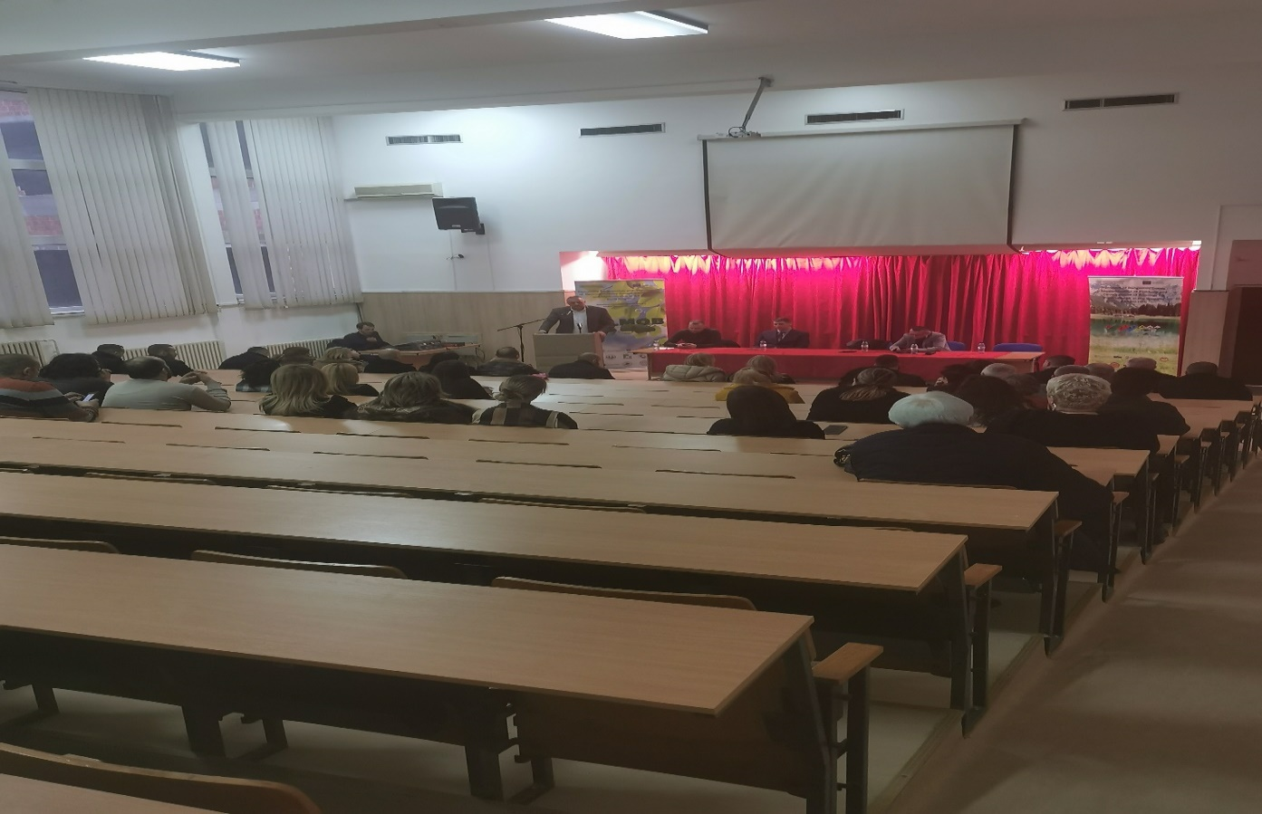  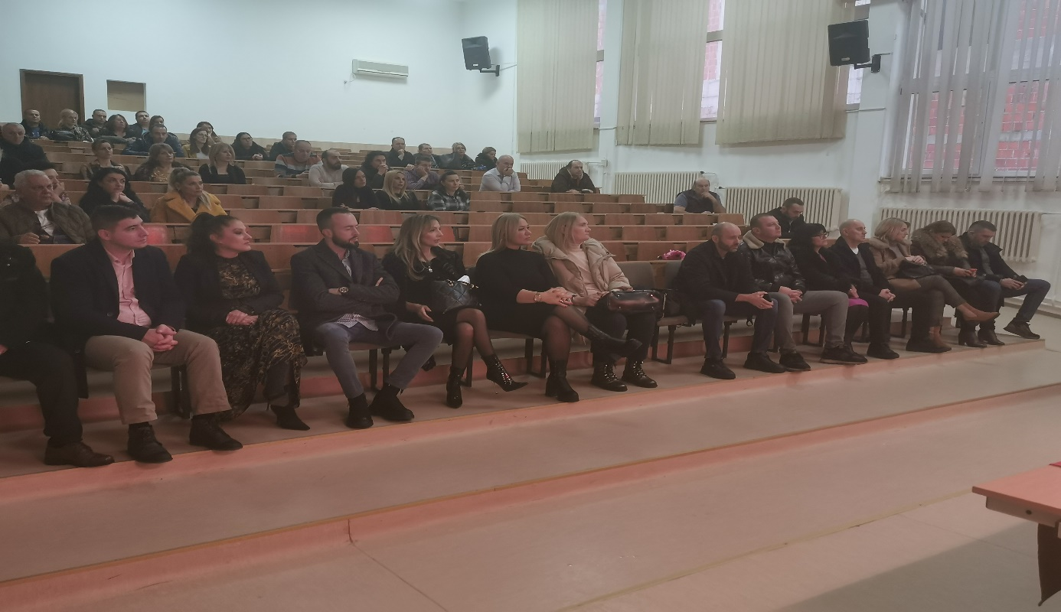  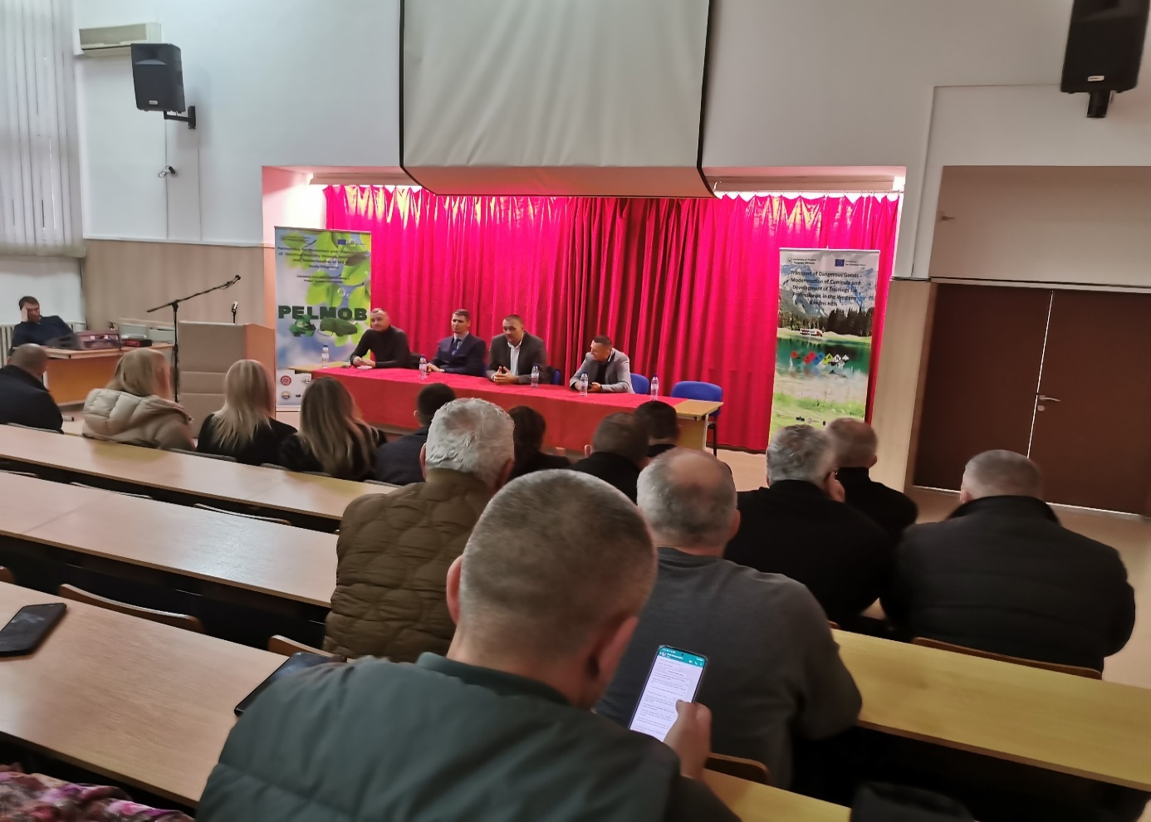  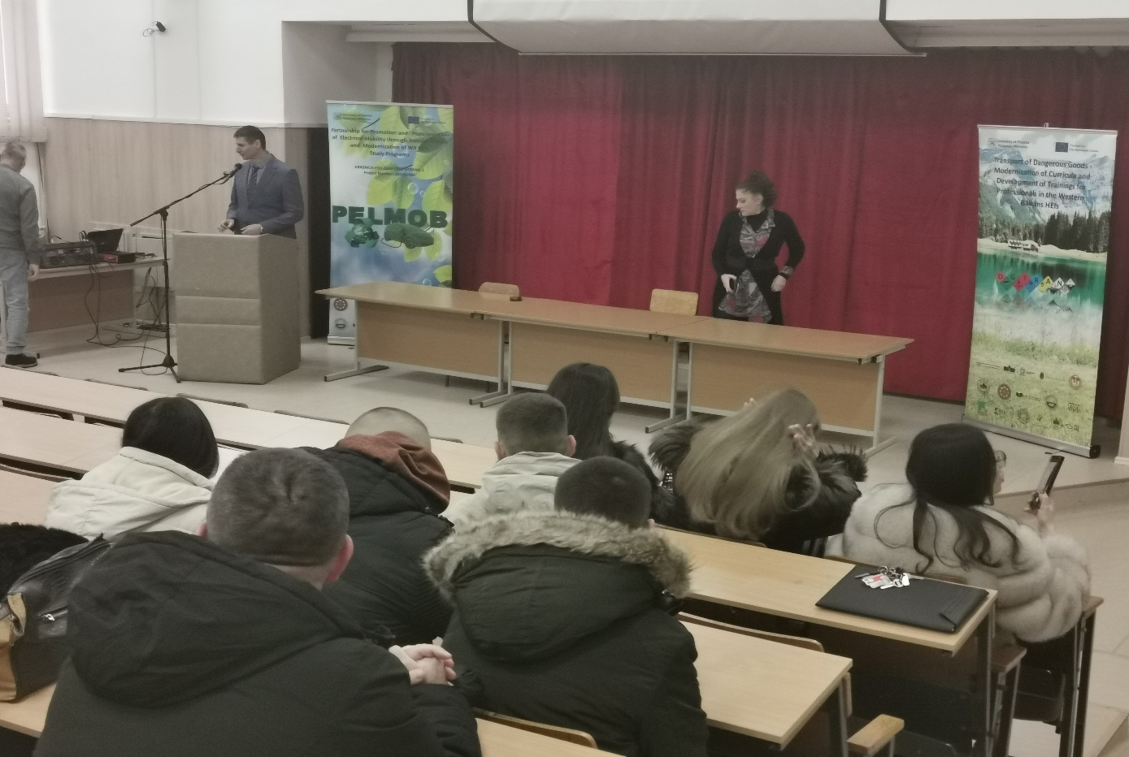  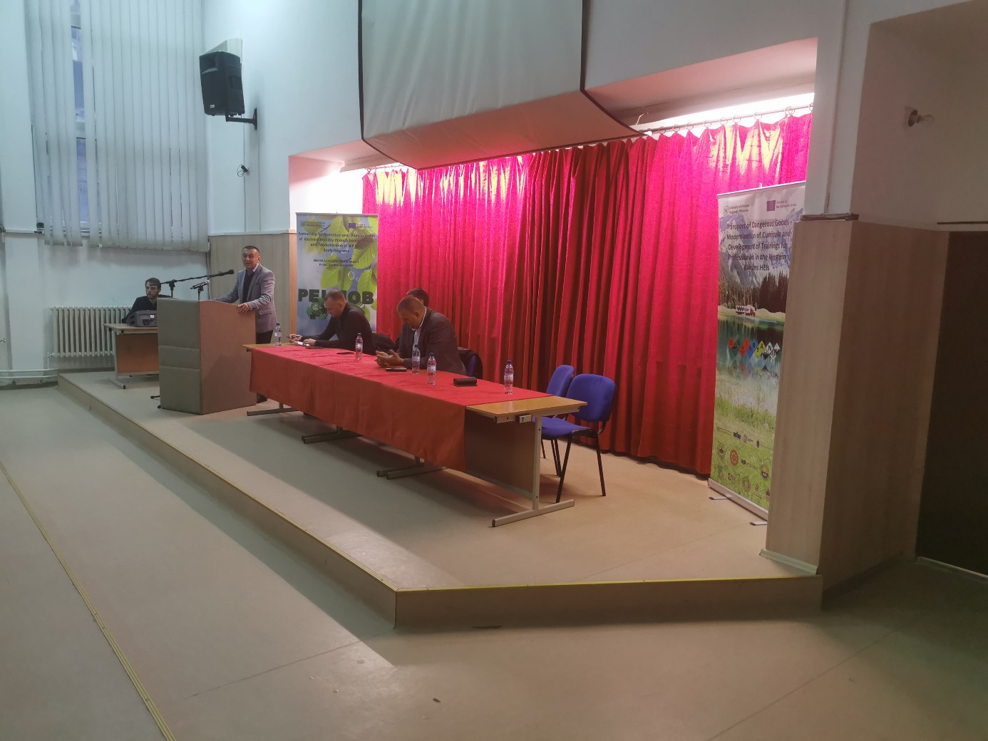
Other personal remarks

