EVENT REPORT FORM

Project title | Partnership for Promotion and Popularization of Electrical Mobility through Transformation and Modernization of WB HEIs Study Programs
Project acronym | PELMOB
Project reference number | 101082860/ERASMUS-EDU-2022-CBHE-STRAND-2
Coordinator | University of Mitrovica
Project start date | December 01, 2022
Project duration | 36 months

"Funded by the European Union. Views and opinions expressed are however those of the author(s) only and do not necessarily reflect those of the European Union. Neither the European Union nor the granting authority can be."

EVENT DESCRIPTION

Date | 9/5/2023
Author | Nebojsa Arsic, Aleksandra Petrovic, Julijana Vrzic
Institution | University of Mitrovica (UPKM)
Event title | FTS Open door

Event description:
On May 9, 2023 at the Faculty of Technical Sciences of the University in Pristina in Kosovska Mitrovica organized Open door day. The promotional event has taken place in order to promote study programs and laboratories to future students. During this event and the ongoing Erasmus+ projects implemented at the FTS – UPKM have been promoted to the participants. Every year FTS Dean, Vice-deans as well as teaching staff of the FTS especially promote future plans for further modernization of the study programs. This year special focus was put on the DGTRANS and PELMOB Erasmus + projects in this sense.
Plans for accreditation new bachelor study program related to transport and traffic engineering with the specific subjects related to transportation of dangers goods as well as modernization bachelor study program in the field of electrical and computer engineering with new and updated courses related to electrical mobility were presented to potential freshmen on order to attract them to enroll FTS, presented to students during the laboratory visit.
The FTS UPKM teaching and administrative staff as well as students and all interested citizens have participated in the event. Also, all directors of the high schools were present, together with high school graduates and other interested citizens.
FTS vice-deans addressed to attendees in the amphitheater of the FTS and welcomed all participants. After welcome speech all present could visit the FTS laboratories where the laboratory equipment which will be purchased within the DGTRANS and PELMOB Erasmus + projects were presented to future students.
This occasion, also, has been used by teaching staff who are part of the project team to familiarize the future students with the possibility for the applying for students internship within DGTRANS and PELMOB project and gaining the practical skills valuable for the labour market demands today.

This event has been published on the local TV stations, one of them is available at the following link
https://youtu.be/kSrFTkLZ1jk?si=quW7Y_usYrmp1RSn

Attachment

Photos (jpg) | 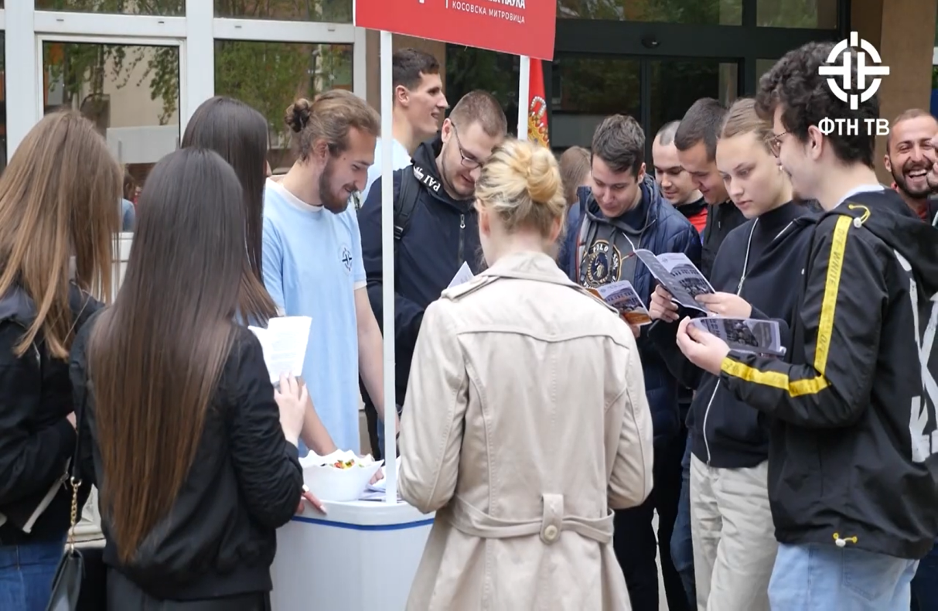  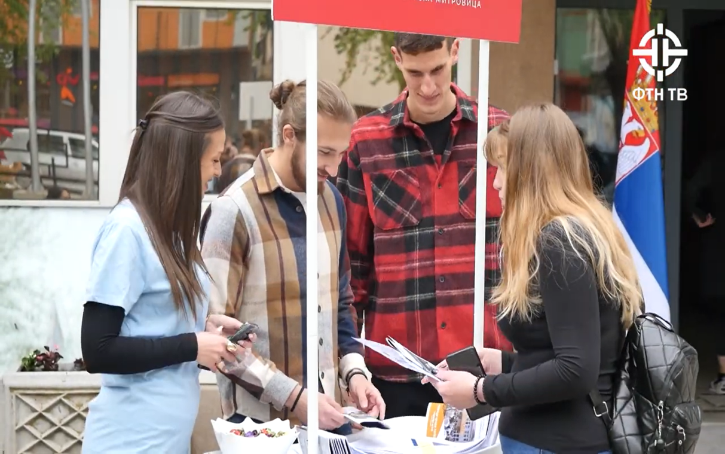  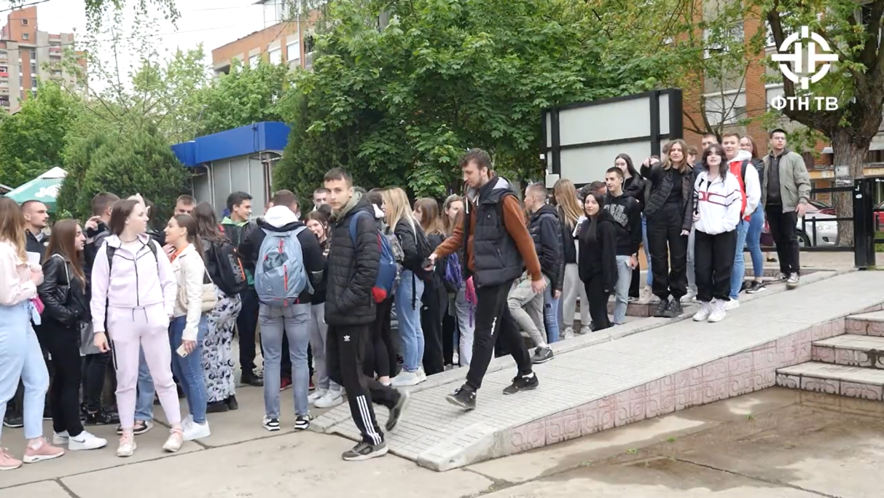  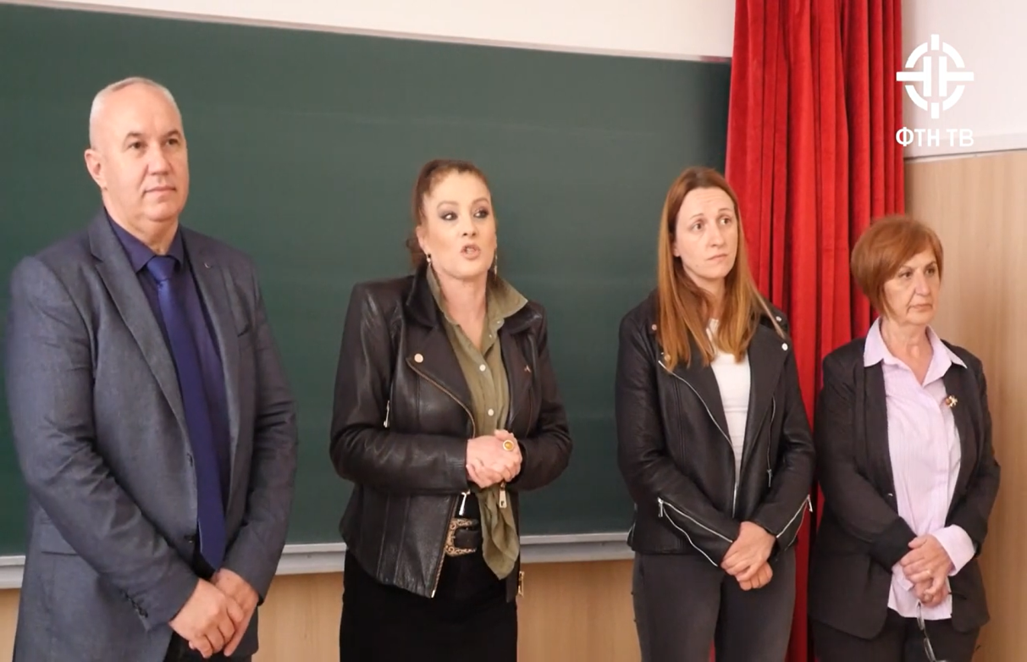
Other personal remarks

