EVENT REPORT FORM

Project title | Partnership for Promotion and Popularization of Electrical Mobility through Transformation and Modernization of WB HEIs Study Programs
Project acronym | PELMOB
Project reference number | 101082860/ERASMUS-EDU-2022-CBHE-STRAND-2
Coordinator | University of Mitrovica
Project start date | December 01, 2022
Project duration | 36 months

"Funded by the European Union. Views and opinions expressed are however those of the author(s) only and do not necessarily reflect those of the European Union. Neither the European Union nor the granting authority can be."

EVENT DESCRIPTION

Date | 7/12/2022
Author | Nebojsa Arsic, Aleksandra Petrovic, Branimir Jaksic
Institution | University of Mitrovica (UPKM)
Event title | Erasmus+ Info Day

Event description:
In the Rectorate of the University of Mitrovica, on December 7, 2022, an Erasmus+ Info day was held, which aimed to promote European Union programs aimed at education, training, youth and sports and announce new competitions for projects within the Erasmus+ program for 2022 a year. The event was attended by prof. Dr. Nebojša Arsić, rector of the University of Mitrovica, Mr. Goran Lazić, project officer in the Erasmus+ office in Kosovska Mitrovica, associates in the Office for International Cooperation of the University, Erasmus+ coordinators of the faculty, project coordinators at the University, teachers and students of the faculty of the University of Mitrovica.
The event was opened by the rector of the University of Mitrovica, Prof. Dr. Nebojša Arsić, who pointed out the importance of this program for the improvement and reform of the University and presented the results that our university achieved by participating in the Erasmus+ program. The Rector emphasized that the University administration provides support to employees in the preparation and implementation of projects and invited teachers and students to get involved and contribute to the development and internationalization of the University.
At the Info day of the Erasmus+ program, two coordinating projects and one partner project of the University, which were approved in the last call, were presented. Approved projects were presented during this event.
The DGTRANS & PELMOB projects were presented at the Erasmus+ Info Day. Also, detailed work plan, as well as specific objectives, consortium members and upcoming activities that will be implemented within the DGTRANS & PELMOB project were presented by Prof. Dr. Aleksandra Petrović and Prof. Dr. Branimir Jakšić.
Detailed information about the new call for submission of Erasmus+ projects for 2023 was presented by the project officer at the Erasmus+ office in Kosovska Mitrovica, Goran Lazić.
This event has been published on the following link https://youtu.be/BOEnsQFpge8?si=LsneVS7vsMQwWD4d

Attachment

Photos (jpg) | 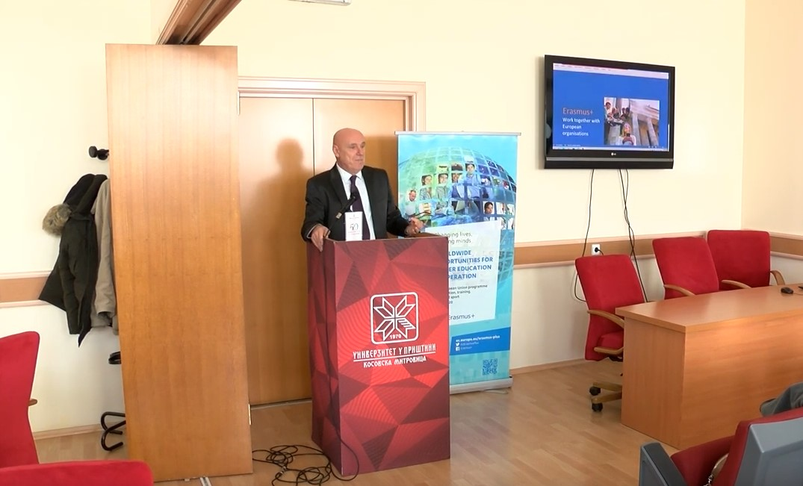  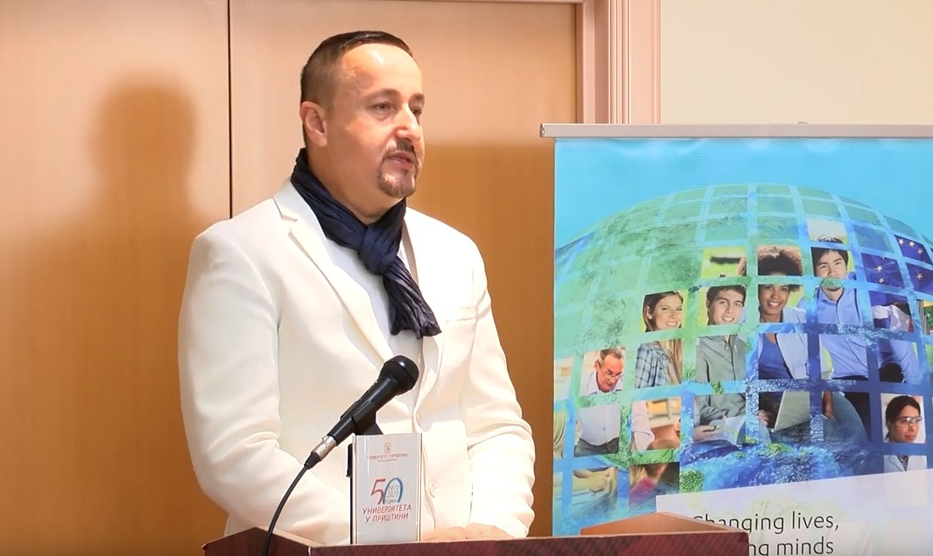  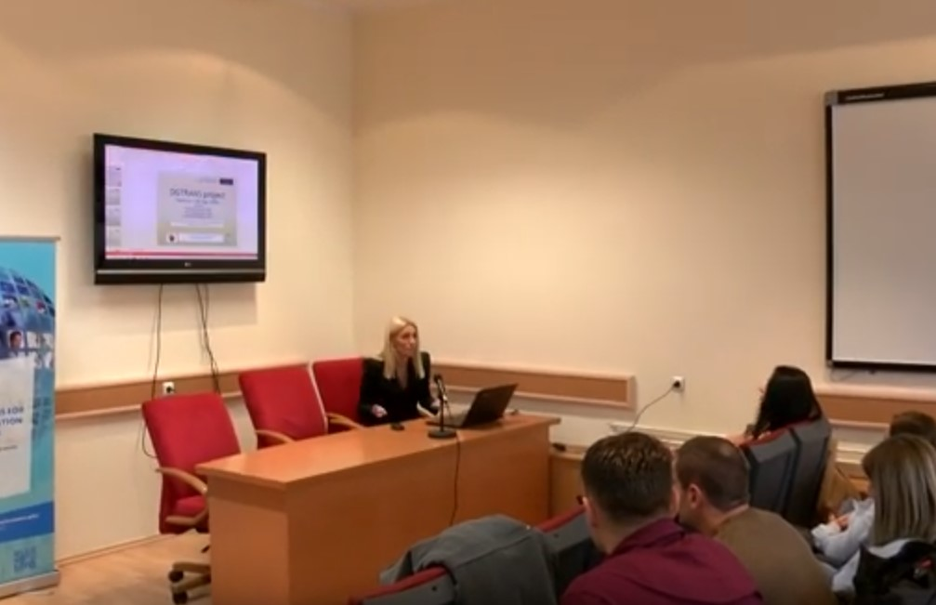  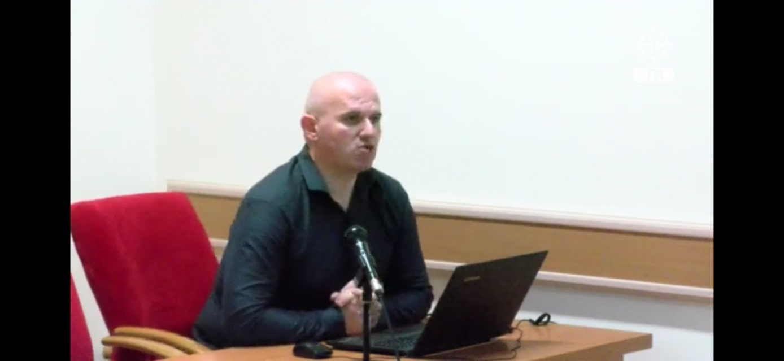  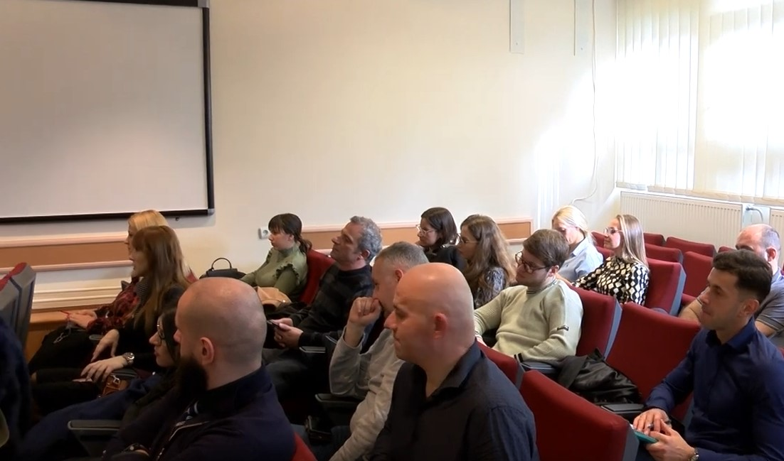
Other personal remarks

